Routing Lab

Create a Log DQL in notebook

fetch logs

| summarize count = count(), by: { winlog.username }

| limit 20

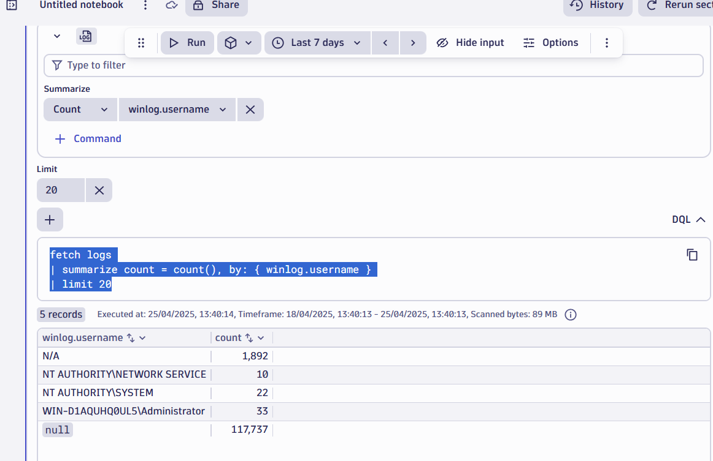

Create a routing in openpipeline

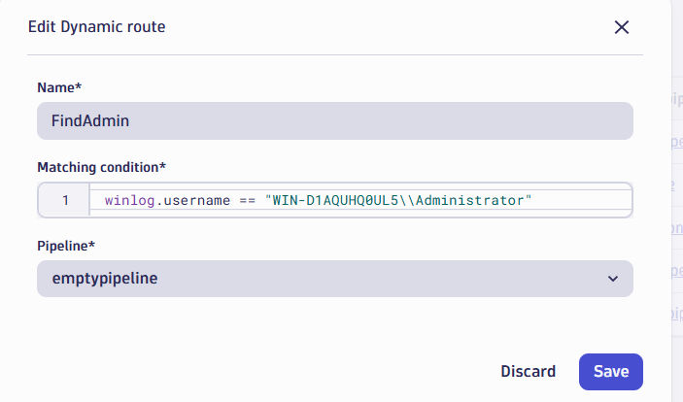

Map a bucket in the pipeline

